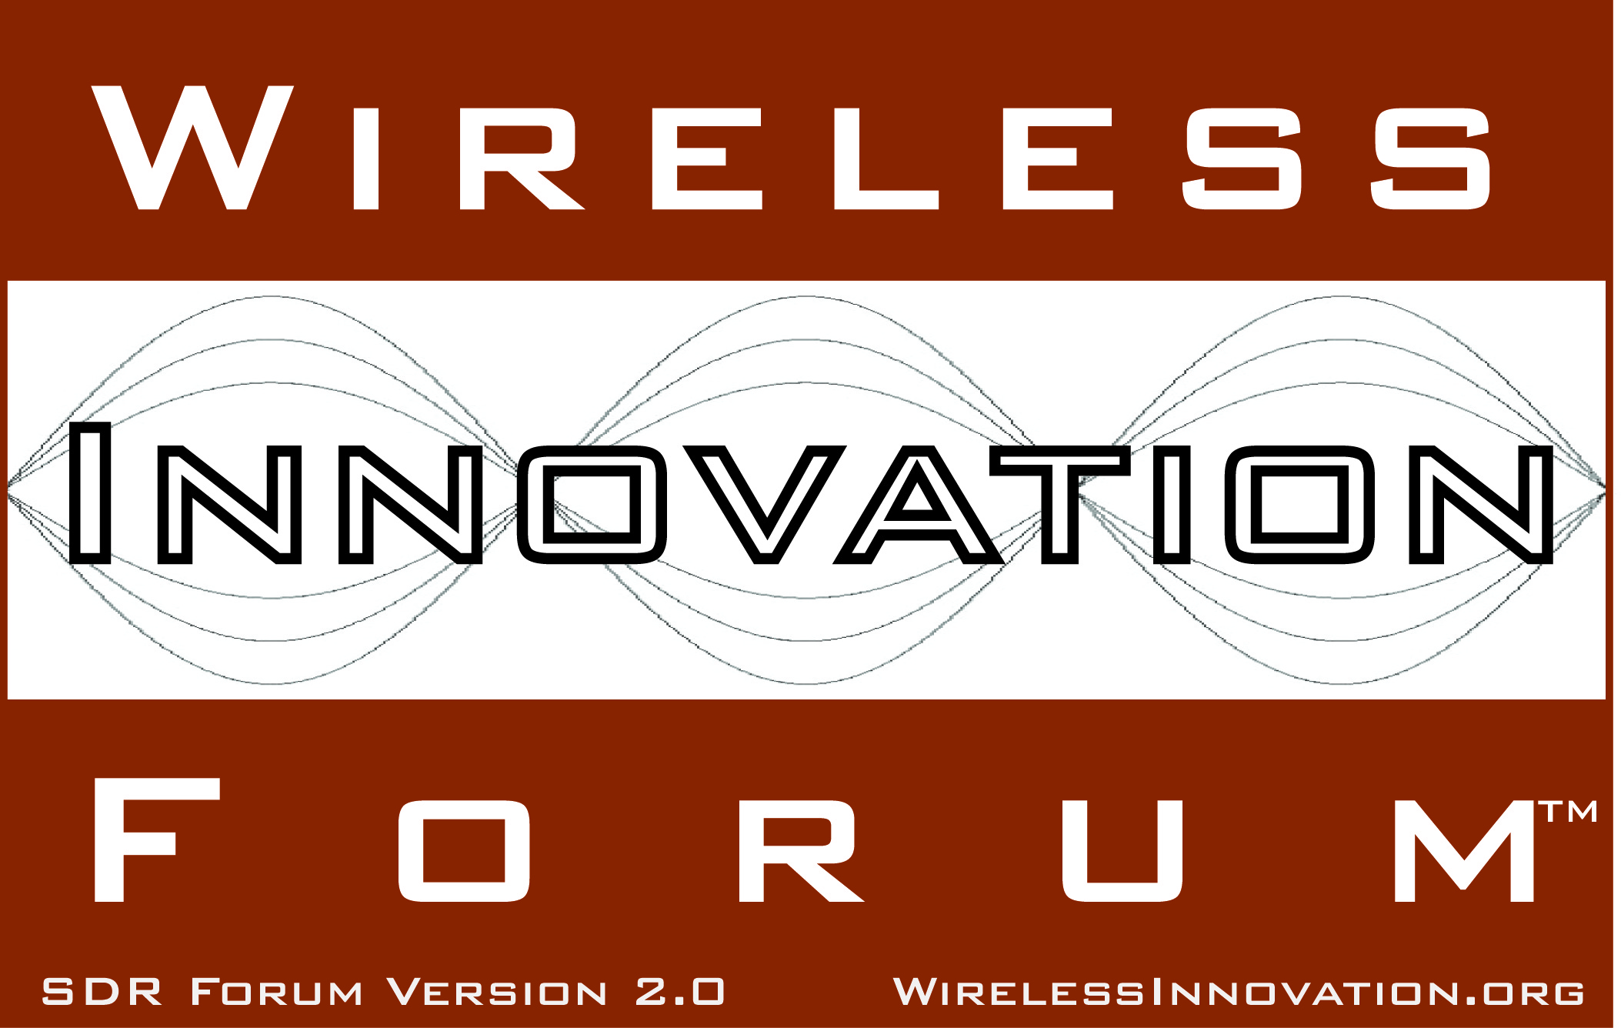

Wireless Innovation Forum Membership Approves Advocacy Agenda

For Immediate Release
Washington, DC - 14 March 2013 – The Wireless Innovation Forum (www.WirelessInnovation.org), a non-profit international industry association dedicated to driving the future of radio communications and systems worldwide, announced today the approval of the Wireless Innovation Forum Advocacy Agenda, enabling the group to be an opinion leader in issues regarding the advanced wireless technologies community.

“The advocacy agenda was developed through broad participation of our members to provide clarity on the positions critical to advancing spectrum utilization and radio technologies for wireless communications,” says the Forum’s Board of Directors Chair Bruce Oberlies of Motorola Solutions (NYSE: MSI).

In 2012, The Wireless Innovation Forum initiated a project to identify the major advocacy positions that the Forum will use to collaborate with governments, regulators, standards bodies, and research sponsors acting as the voice of the wireless innovation community. The advocacy agenda will support the Forum’s mission of advocating for the innovative utilization of spectrum, and advancing radio technologies that support essential or critical communications.

“Our advocacy positions identify and target key areas for innovation and growth in the wireless communications sector. By setting out clear viewpoints on each, we have enhanced our ability to liaise with regulators and technologists, and to support our members' interests,” said the Forum’s Chief Regulatory Officer Keith Nolan of Telecommunications Research Centre (CTVR).

To create the Advocacy Agenda, the Forum’s Regulatory Committee sought participation from the different stakeholders and leveraged the body of work that has been approved by the Forum’s members that advocate positions to advance wireless innovation in spectrum utilization and radio technologies. The Advocacy Agenda is composed of five focus areas:

• Essential and Critical Communications
• Innovation & Competition
• Spectrum
• Security
• Interoperability

Wireless Innovation Forum member representatives have initiated and led multiple work efforts that promote their organization’s specific objectives through the creation of reports, recommendations and specifications that are widely used by the advanced wireless community. The importance of these "work products" is reflected in the fact that over 12,000 individual documents were downloaded from the document library in 2012 alone. Additional information about the Forum’s groups and projects can be found here: http://www.wirelessinnovation.org/Current_Projects.

Download the complete Advocacy Agenda here: http://groups.winnforum.org/Advocacy_Agenda.

# # #
About the Wireless Innovation Forum
Established in 1996, The Wireless Innovation Forum (SDR Forum Version 2.0) is a non-profit mutual benefit corporation dedicated to driving technology innovation in commercial, civil, and defense communications worldwide. Members bring a broad base of experience in Software Defined Radio (SDR), Cognitive Radio(CR) and Dynamic Spectrum Access (DSA) technologies in diverse markets and at all levels of the wireless value chain to address emerging wireless communications requirements. To learn more about The Wireless Innovation Forum, its meetings and membership benefits, visit www.WirelessInnovation.org.

Editorial Contacts
Lee Pucker, 604-828-9876, Lee.Pucker@wirelessinnovation.org or
Stephanie Hamill, 970-290-9543 or Stephanie.Hamill@wirelessinnovation.org

